## tabs table

## Fields

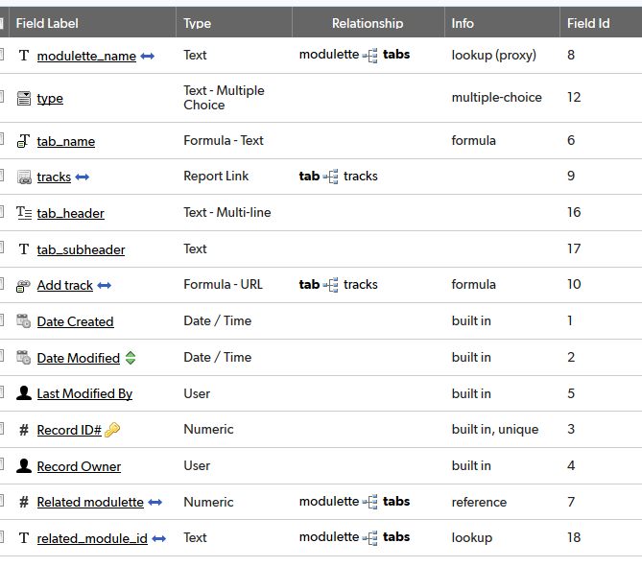

## Relationships

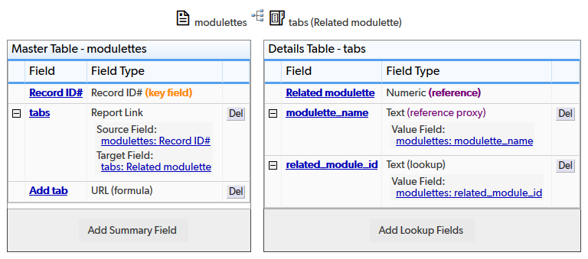

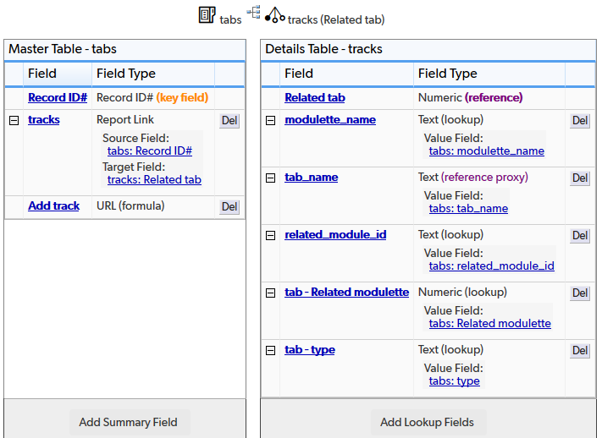

## Field settings

Note: Built-in fields use the default settings

modulette_name 3

type 3

tab_name 3

tracks 3

tab_header 3

tab_subheader 3

Add track 3

Related modulette 3

related_module_id 3

# modulette_name

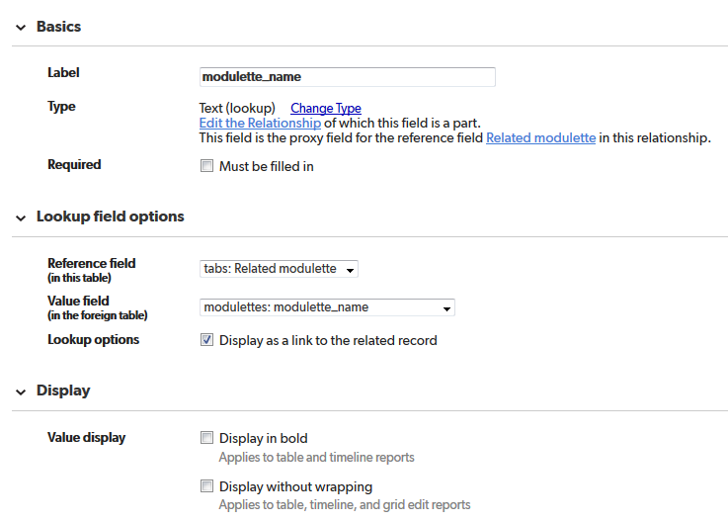

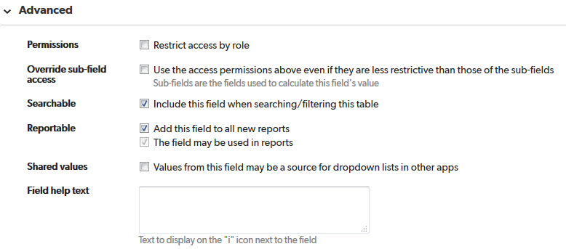

# type

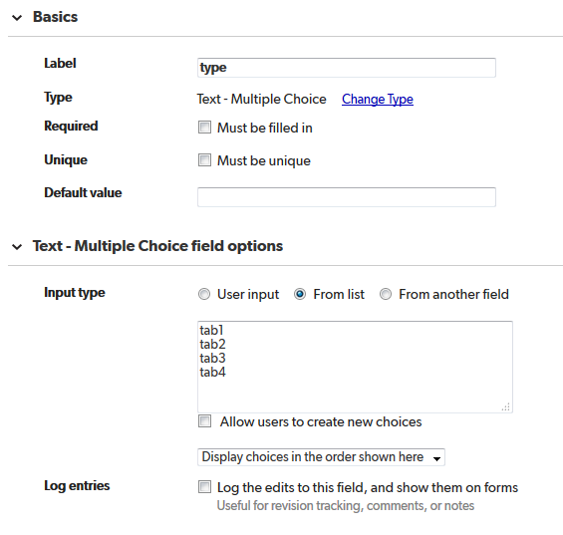

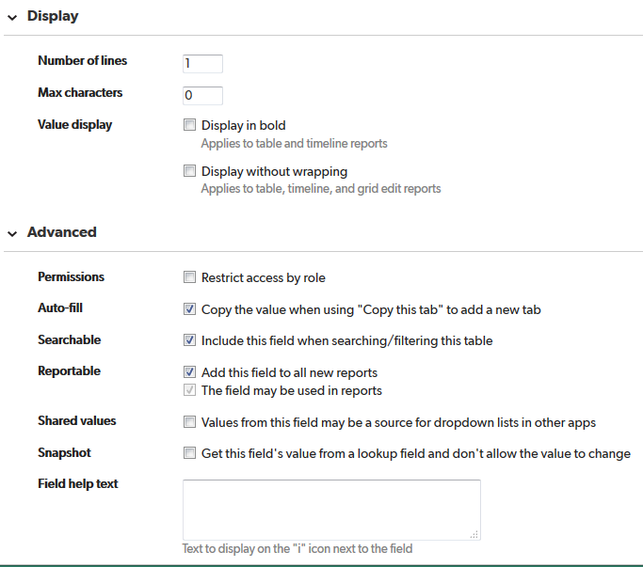

# tab_name

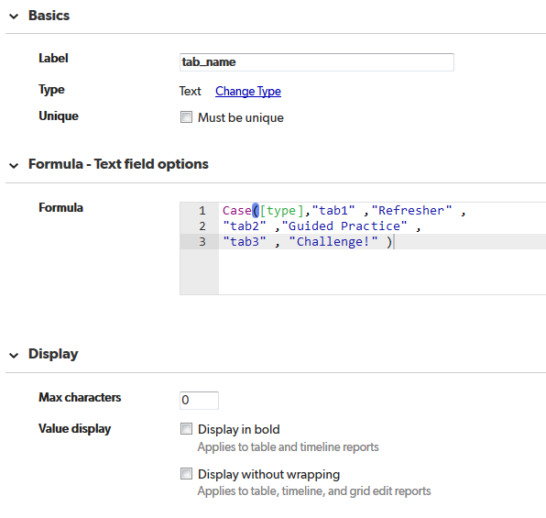

Case([type],"tab1" ,"Refresher" ,

"tab2" ,"Guided Practice" ,

"tab3" , "Challenge!" )

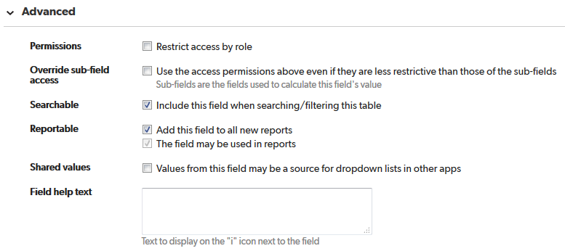

# tracks

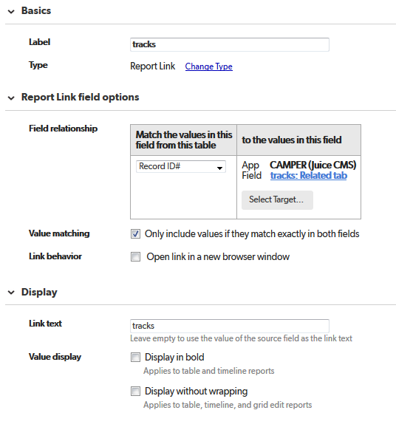

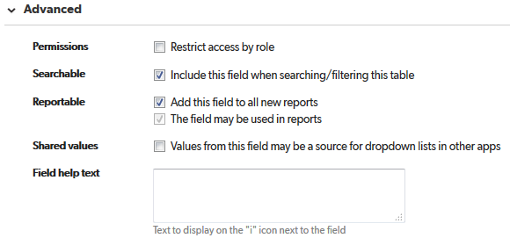

# tab_header

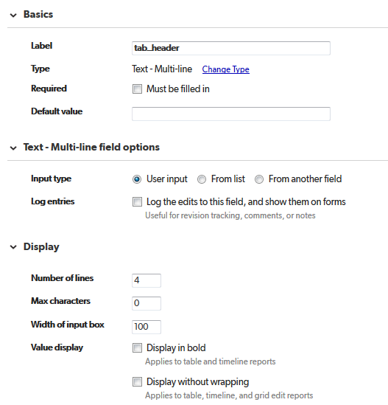

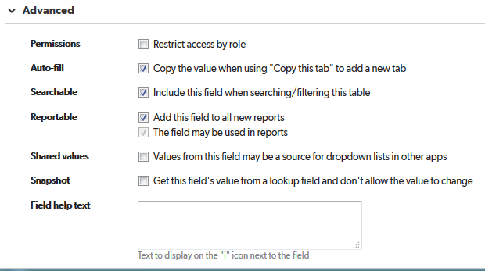

# tab_subheader

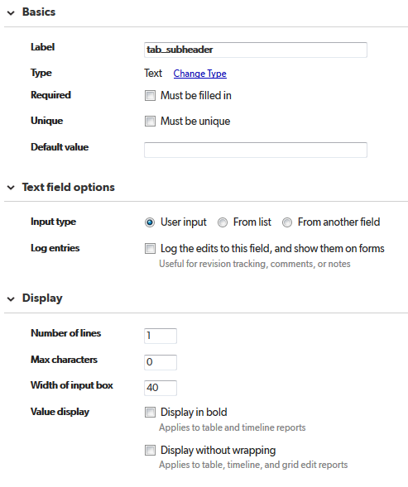

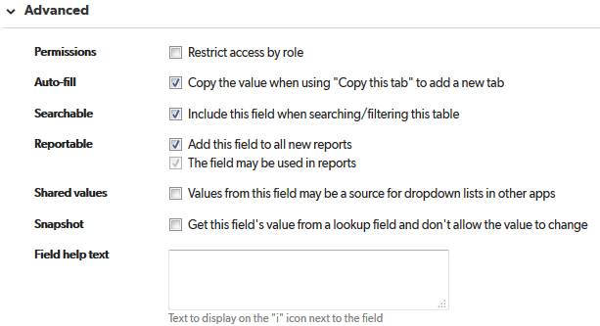

# Add track

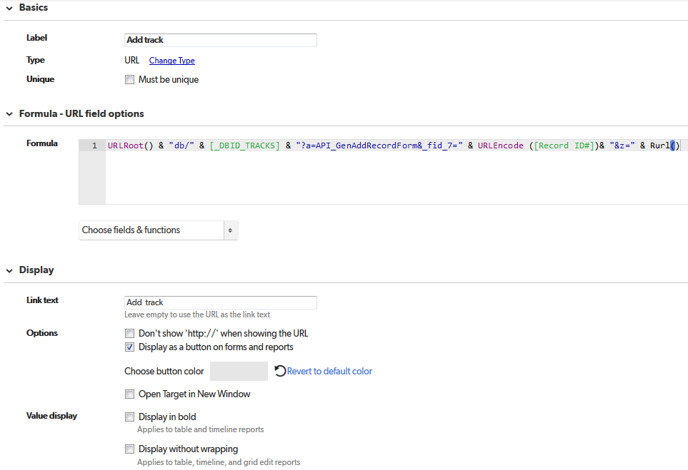

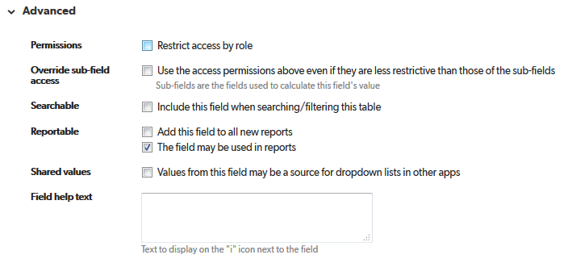

# Related modulette

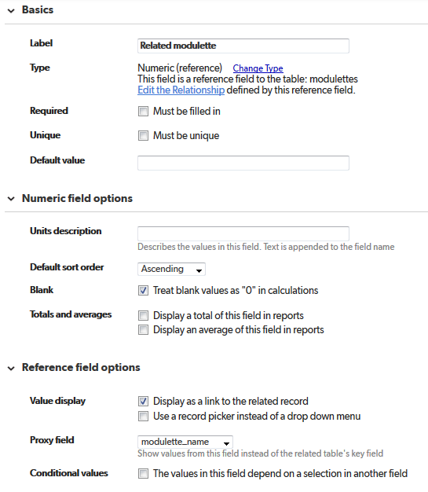

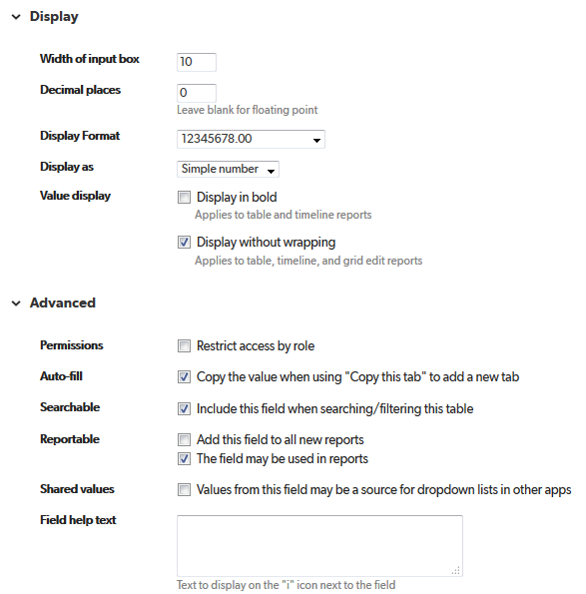

# related_module_id

